**A Mars Rover For Studying The Subsurface Areas Using Seismic Exploration**

“Nazarbayev Intellectual school of Science and Mathematics in Taldykorgan”,

“Nazarbayev Intellectual school of Science and Mathematics in Nauryzbay district of Almaty”, branches of Autonomous Educational organization “Nazarbayev Intellectualschools”

Authors: Yenlik Maman , Saniya Shokhan

Grade: 11

Teacher: Avdunin Nicolai

Team: LikiSanctum

**Table Of Contests**

Table of Contents

1. Abstract 3

2. Introduction 5

3. Research Section 8

3.1. Lava tubes 8

3.2. Subsurface Structure on Mars 11

4. Project development 13

4.1. Robot Structure 14

4.2. Operating Principle of the Robot 14

4.3. Description of the Vibration Unit 16

4.4. Vibrational System Calculations 17

4.5. Energy Supply System of the Robot 19

4.6. Robot Chassis 22

4.7. Vibration Measurement Sensors 23

4.8. Use of Neural Networks 23

5. Robot Communication with Earth 25

6. Mission Launch Calculations 26

7. Flight and Landing Calculations of the Mission 27

8. Conclusions 28

9. Sources 29

# Abstract

**Research Objective:**  The aim of this project is to develop an autonomous robot for the exploration of subsurface structures in the vicinity of these pits using seismic surveying methods, because orbital imaging of the Moon and Mars has revealed the presence of vertical pits on their surfaces, which may represent entrances to lava tubes formed as a result of intense volcanic activity. These tubes could serve as ideal shelters from cosmic radiation for future colonies.

**Hypothesis:** If we develop such a robot and successfully deploy it to the surface of Mars near one of these pits, we will be able to determine whether lava tubes are present, as well as identify their size, depth, and structure. This information will help us understand whether they can be used as shelters. By scanning the subsurface, we may also detect presence of water ice, which could become an important resource for future missions.

**Research stages:** Stage 1 - analysis of the problem and formulation of the goal. Stage 2 - study and collection of theoretical background. Stage 3 - concept development. Stage 4 - robot modeling and development. Stage 5 - testing the robot in practice. Stage 6 - analysis of results and conclusions.

**Research methods:** Study of the problem, search and analysis of information, design and modeling of the device, programming, calculations of physical processes, testing.

**Novelty of the research and degree of independence:** This work on the creation of an autonomous device with seismic exploration is completely new; no such projects have been created before. The student developed the entire project independently, with consultations on the selection of optimal technologies.

**Results and conclusions:** The result is a fully completed project for a Mars rover capable of conducting seismic exploration, tested in near-real conditions.

**Areas of practical application of the results:** Based on the experiments, assistance in the development of future space missions to the Moon and Mars

# Introduction

Leading countries around the world are developing plans to land humans on nearby celestial bodies, such as the Moon and Mars. For example, the United States is developing the Artemis mission to return to the Moon, while China is successfully advancing the Chang’e program for the systematic exploration of the Moon, as well as the Tianwen-3 mission for the study of Mars.

|  |  |  |
| --- | --- | --- |
| **№** | **Country** | **Description** |
| 1 | USA (SpaceX) | They plan to send the first crewed mission to Mars in the late 2020s to early 2030s [1]. The Starship rocket is being developed to transport cargo and humans to Mars. Elon Musk has spoken about creating a self-sustaining city on Mars (with a population of one million) within 50–100 years. |
| 2 | USA(NASA) | A crewed mission to Mars is not expected before the late 2030s. The Perseverance rover and plans are in place to return samples from Mars to Earth. |
| 3 | China (CNSA) | They plan to send a crewed mission to Mars between 2035 and 2050. The Tianwen-1 probe, lander, and Zhurong rover are already being in use [2]. |

Tabel 1 Other planned missions

When these plans are put into action, the missions will face many difficulties, including high radiation levels and extreme temperature variations on the surface.

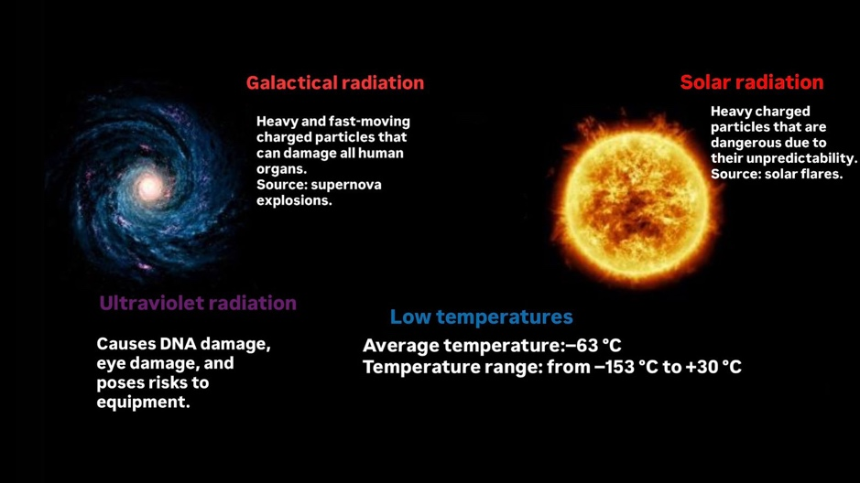

Figure 1Harmful factors on the surface of Mars

At the same time, vertical pits have been discovered on the surface of the Moon and Mars. These pits may lead to underground caves of volcanic origin. Such caves could provide natural protection from radiation and extreme temperature changes; however, their existence has not yet been confirmed.

**Aim:** The aim of the project is to develop an autonomous robot for exploring the subsurface of Mars or the Moon using seismic surveying technology.

**Project objectives:**

1. To study harmful factors on the surface of celestial bodies and possible methods of protection;
2. To investigate how the structure of an underground cave can be determined without entering it;
3. To design a robot for seismic exploration;
4. To assemble and program the robot;
5. To test the effectiveness of this method in practice;
6. To analyze the obtained results.

To address this problem, the method of seismic surveying was selected. This method makes it possible to “scan” the subsurface and identify underground structures. Voids and their internal structure can be detected on seismic maps. The device will be based on a mobile rover platform and will be reusable, allowing a larger area to be explored.

In addition, seismic exploration may help detect deposits of water ice. Ice can serve as a source of oxygen for breathing and hydrogen for fuel, which would be extremely valuable for future missions.

# Research Section

## Lava tubes

Large vertical pits with diameters of 200 meters or more have been observed on the surface of the Moon and Mars from orbit. These formations are clearly not typical impact craters.

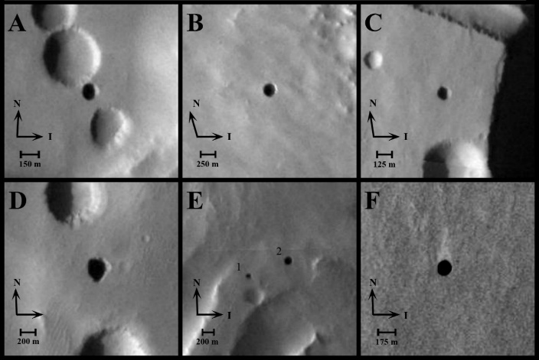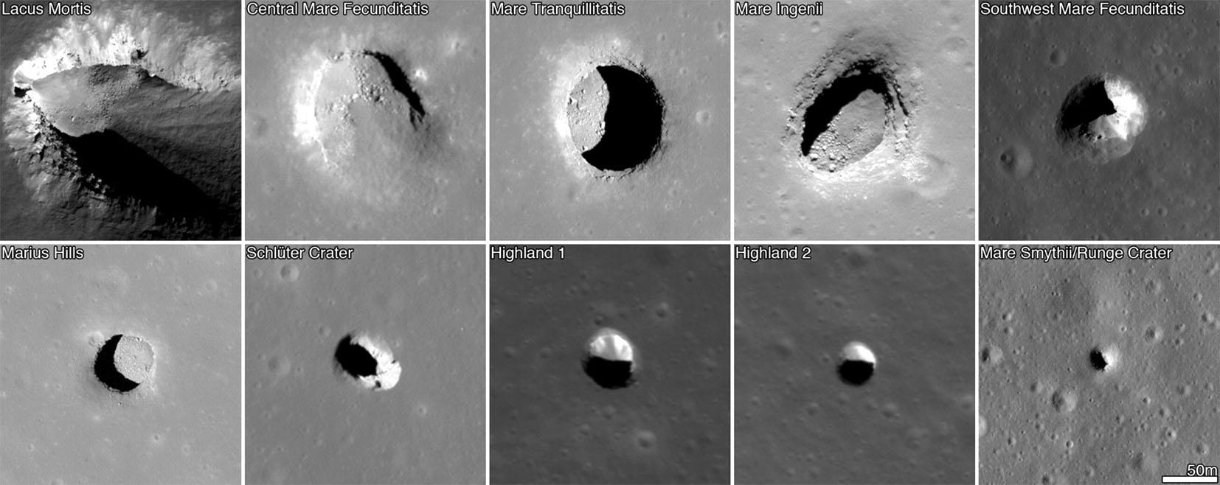

*Figure 2 Pits on Mars: (A) Dena, Figure 3 Pits on the surface of the Moon*

(B)Chloe, (C) Wendy, (D) Annie, (E)

Abby and Nikki, (F) Jeanne

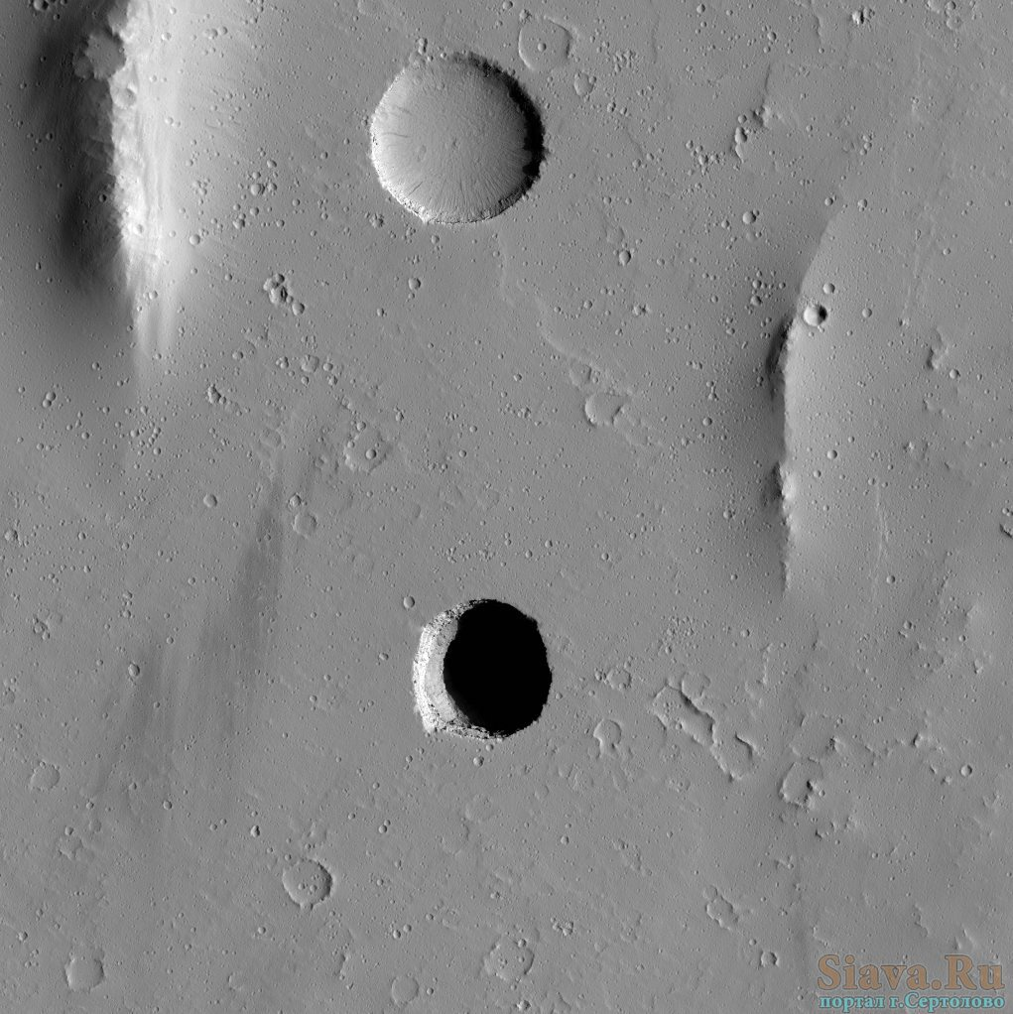

*Figure 4 Difference between a typical crater and a pit*

These pits may be entrances to hypothetical lava tubes—volcanic caves formed as a result of intense volcanic activity. We know that both the Moon and Mars were volcanically active in the past. These volcanic structures could extend for many kilometers, but their actual existence has not yet been confirmed.

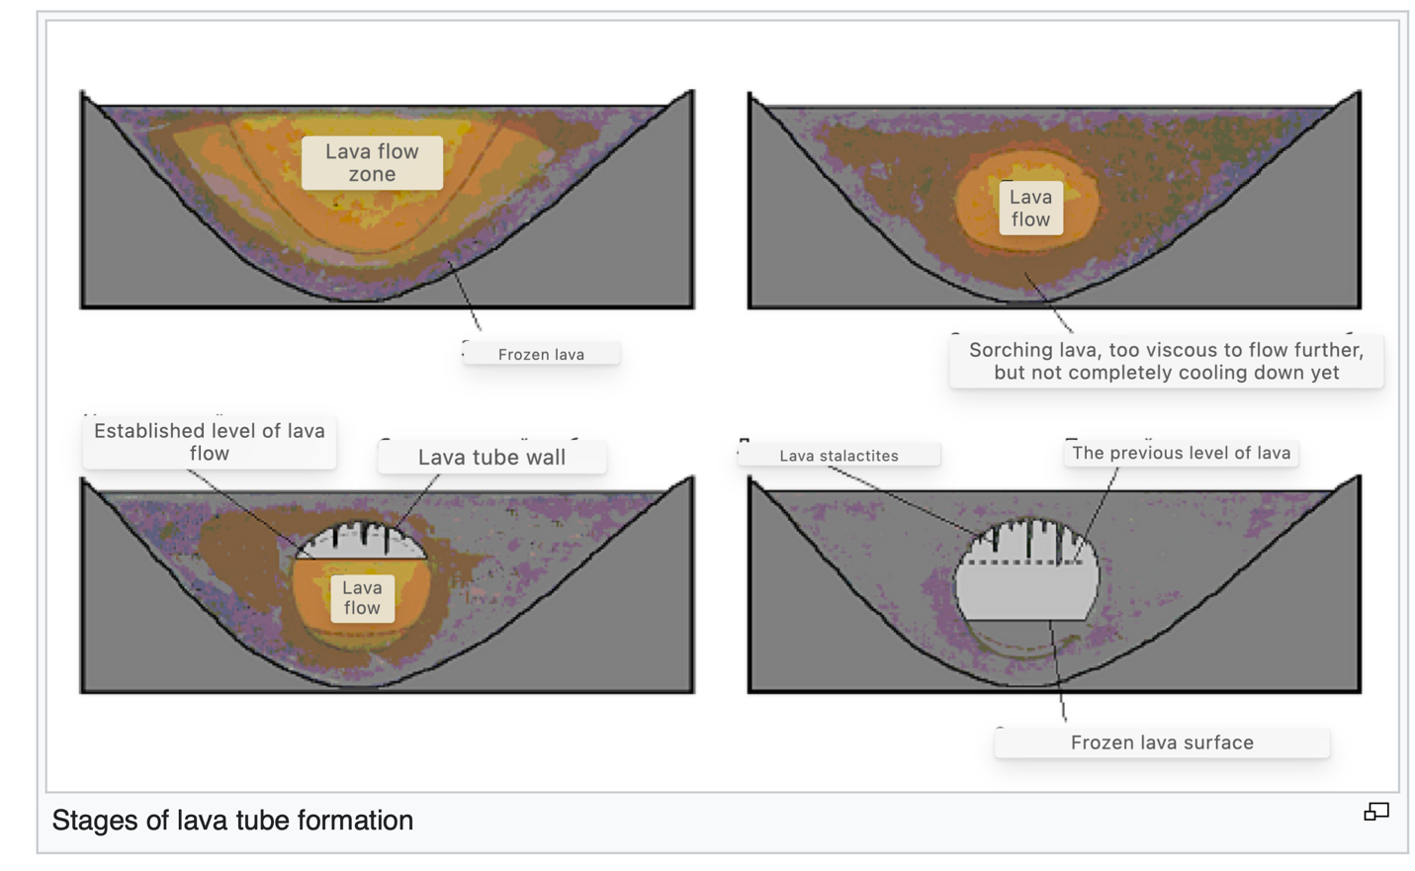

Figure 5 The formation process of lava tubes

Lava caves provide excellent protection from harmful factors; a thick layer of regolith completely blocks radiation and ultraviolet light.

Observations from the Mars Odyssey mission have shown that cave entrances on the slopes of the Arsia volcano on Mars are warmer than the surrounding rock by approximately 20–30 Kelvin. This suggests that heat is retained inside, and the temperature there is estimated to range between −20 and −40 degrees Celsius [3]

These findings offer promising prospects for establishing habitats inside the caves. They would be fully protected from radiation, which would allow the living modules to be very light and inexpensive, potentially using inflatable structures.

Additionally, in deep caves there is a chance of discovering primitive single-celled life forms. 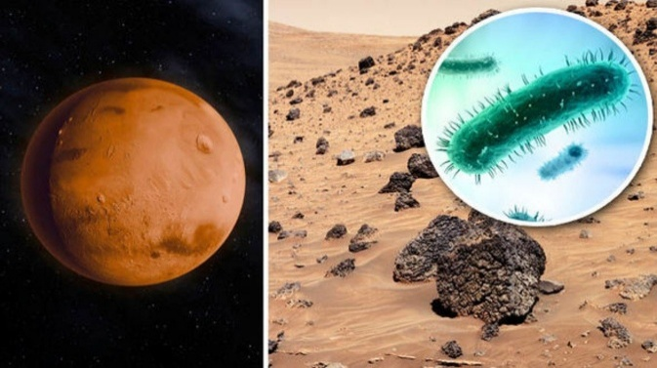

Figure 6 Possible bacteria on Mars

From all of the above, the question arises: how can we determine whether these caves actually exist, and what are their size and structure?

## Subsurface Structure on Mars

According to orbital reconnaissance data obtained from the Mars Reconnaissance Orbiter and the InSight mission.

|  |  |  |
| --- | --- | --- |
| **Depth** | **Material** | **Characteristics** |
| 0-10 m | Dust, sand, and ash | Loose, granular, porous |
| 10-100 m | Lava basalt, tuffs | Dense, varying with loose rocks. |
| 10- 100 m | Possible water ice (depending on the region), dry ice | Dense |
| 500- 1000 m | Solidified magma | High density |

*Tabel 2 General overview of Mars’ subsurface structure*

Based on data obtained from orbital imaging, the depth of many pits is estimated to range from 20 to 100 meters, with some pits being even deeper.

Considering that the subsurface down to 100 meters consists mainly of volcanic rocks, it is likely that lava tubes could form in these areas.

**5.3. Seismic Surveying**

We conducted an analysis of various methods for studying the geological structure of rocks and found that, to investigate the structure of rocks on Mars with minimal financial costs, the best approach is seismic surveying. This method allows us to learn about the structure of caves without entering them, as all research can be carried out entirely from the surface. For this purpose, it is most practical to use an autonomous robot.

Seismic surveying is widely used by geological services to search for underground resources, such as oil deposits, or to determine the layers of rock in a given area—for example, when selecting a site for constructing a power plant.

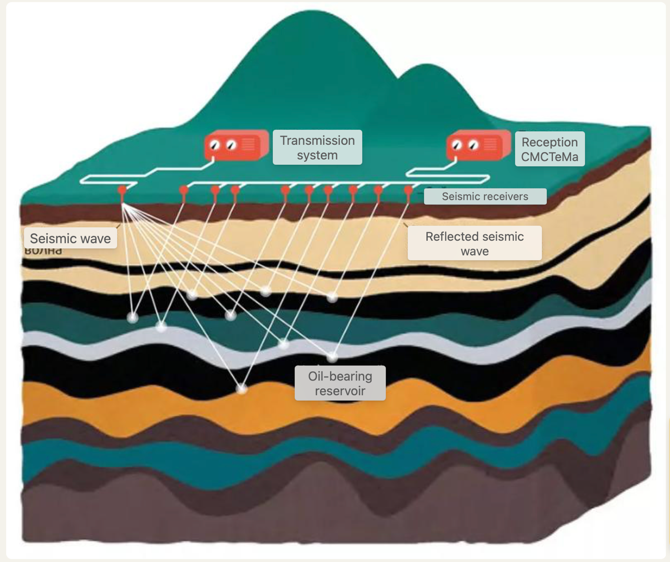

*Figure 7 Principle of seismic surveying*

The principle of seismic exploration is based on the use of seismic sensors that are sensitive to ground vibrations. These sensors are installed at specific locations within the exploration area, typically at intervals of approximately 200 meters. A powerful seismic vibrator, which is a heavy vehicle, generates strong seismic waves that propagate into the subsurface rock formations. The waves are reflected from internal geological structures and are then detected by the sensors.

If the rocks are dense and solid, the waves are strongly reflected. In contrast, softer formations tend to scatter the waves, while the presence of cavities may result in significant signal loss.When the sensors are placed at sufficient distances to capture the returning waves, differences in wave refraction and travel time across various sections are recorded. These variations make it possible to construct a detailed image of the subsurface structure.

# Project development

To address the challenge of studying the subsurface of Mars using the most accessible and cost-effective technologies, we decided to design and assemble a fully functional prototype of a robotic system for seismic exploration of the Martian subsurface. The proposed system is intended to investigate depths of up to 100 meters, as this range is considered the most promising for the detection of potential lava formations.

## Robot Structure

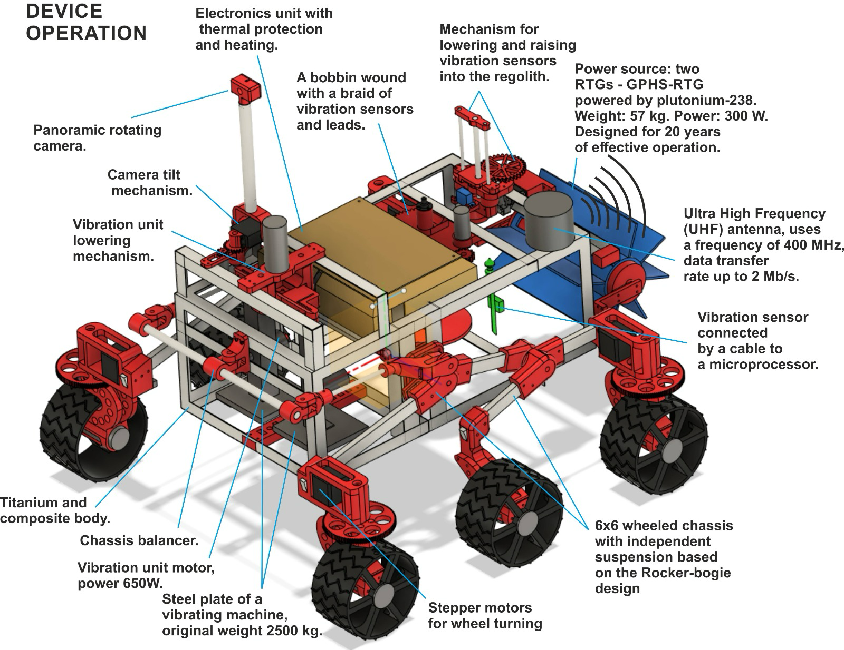

*Figure 8* ***Overall Structural Layout Scheme***

## Operating Principle of the Robot

1. The robot lands in an area where there are ground depressions and possible cave entrances. The landing site will be located approximately 1 kilometer from the depression, after which the robot autonomously travels to the research location.
2. At the research site, the robot moves forward, unspooling a cable, and uses a special mechanism to install vibration sensors into the regolith at intervals of every 5 meters. The sensors are placed in a line, positioned perpendicular to the assumed direction of the hypothetical cave.
3. After installing all the sensors, the robot lowers a seismic vibrator onto the regolith and presses it down using its own weight.
4. The robot activates the seismic vibrator. Seismic waves propagate to depths of up to 100 meters, reflect off internal structures, and are detected by the seismic sensors.
5. Each sensor transmits data to a microcontroller, and the collected data is then sent to Earth for detailed analysis.
6. Once exploration in this direction is completed, the robot returns and uses the same mechanism to retrieve the sensors and wind the cable back onto the spool.
7. The robot then moves to another sector and repeats the exploration process.

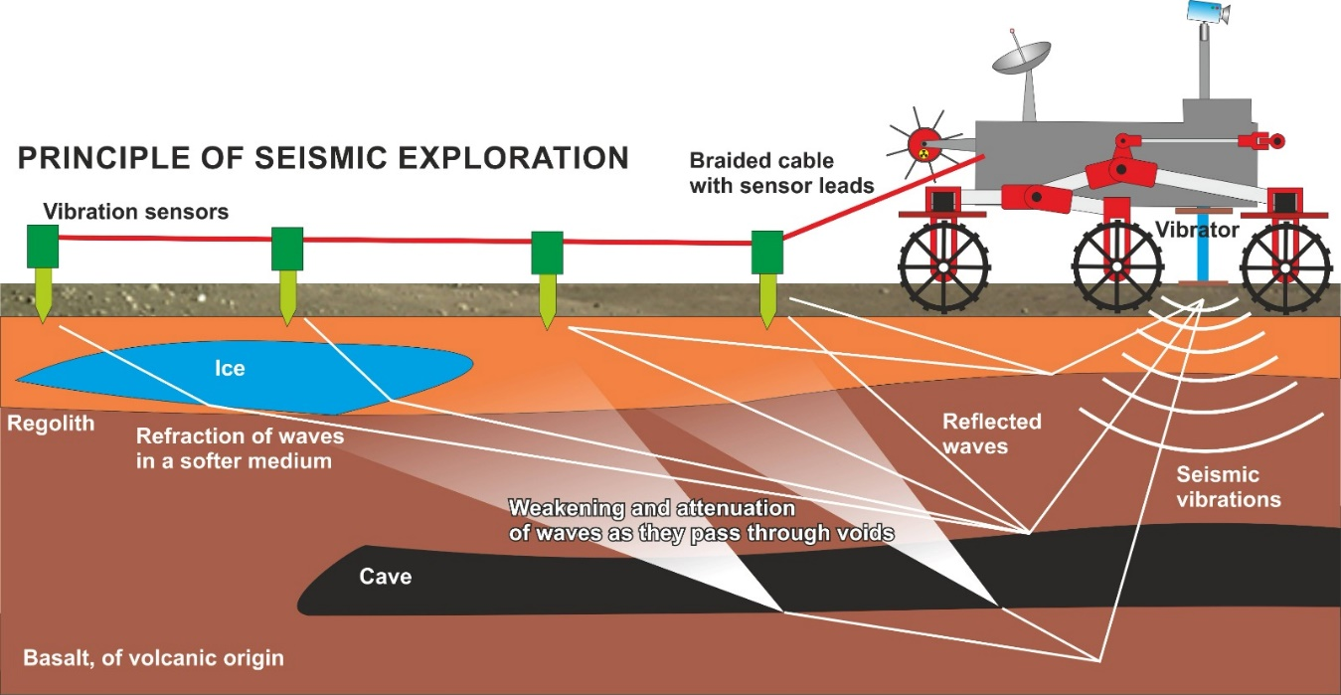

Figure 9 Operational Diagram of the Robot for Seismic Exploration

Thus, by conducting a series of surveys in different directions relative to the presumed location of the hypothetical lava tube, it will be possible to construct a three-dimensional geological map of the subsurface structure. This map will clearly indicate the presence or absence of a lava tube, as well as its structure, dimensions, and ceiling height.

## ****Description of the Vibration Unit****

The main device of the robot is the vibration unit. It consists of a massive metal plate weighing 1 kg in the prototype and 1 ton in the full-scale robot. The base area is 200 square centimeters in the prototype and 2 square meters in the real robot.

This plate can be lowered onto the ground using a special mechanism, where it is pressed firmly against the surface, and raised again when necessary. Seismic vibrations are generated by a powerful electric motor equipped with a massive flywheel, which produces longitudinal (P-type) seismic waves.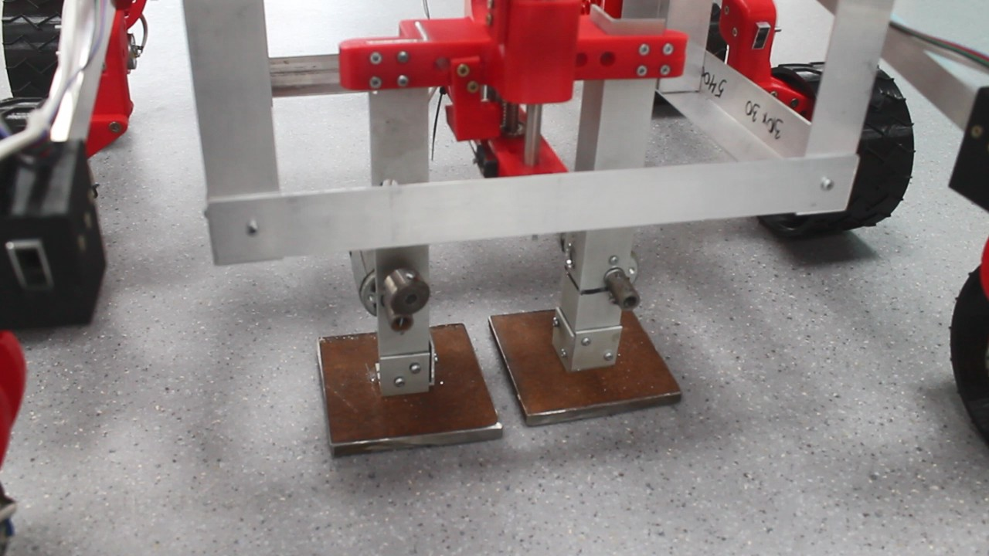

*Figure 10* ***Design of the Vibration Unit***

For exploration to depths of up to 100 meters on Earth, systems with a power output of 2–10 kW and a pulse energy of 10³–10⁴ J are typically used.

On Mars, the conditions are different. Some mission conditions are less favorable, including low gravity, with a free-fall acceleration of approximately 3.71 m/s², and weaker contact between the plate and the ground due to low atmospheric pressure.

However, certain favorable conditions exist. The absence of liquid water significantly reduces seismic wave attenuation.

## Vibrational System Calculations

We will perform calculations. To generate a wave capable of effectively penetrating to a depth of 100 meters, the following conditions must be met:

The wave must propagate for 10 seconds.

The wave must deliver sufficient energy, approximately ${10}^{4}$ J, to ensure that the sensors can detect the reflected signal.

Then, It follows that the power of the seismic wave must be at least 1 kW.  
However, not all of the energy will be transferred into the regolith. Based on the efficiency **(η)** of terrestrial systems, only 5–20% of the power is actually delivered to the ground. From this, we can calculate the required power of the vibration generator:

Next, we calculate the required power of the motor for the vibration system using the following formula:

where:

* — mass of the vibrating element, 1000 kg,
* $A$— amplitude of vibration, 0.001 m,
* $f$— standard frequency for such systems, 20 Hz.

The angular frequency $ω$ can be calculated as:



Substituting the values:

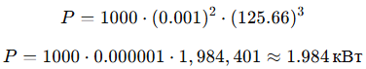

Considering the optimal efficiency of 20% ($η=0.2$), we obtain:



From the calculations, we obtain the following specifications:

Required motor power: 10 kW

Mass of the system: 1000 kg

Vibration amplitude: 1 mm

Vibration frequency: 20 Hz

## Energy Supply System of the Robot

To power the vibration system, a current source with a minimum capacity of 10 kW is required. Standard solar panels cannot be used, as they are unable to provide the necessary energy. Additionally, solar panels may become covered with dust, reducing their efficiency, and they do not operate at night, which poses a risk of the robot freezing.

Furthermore, the power source must provide a voltage of 220 V and sufficient current to operate the system reliably.

The current can be calculated using the formula:  where — efficiency of the power source (for example, 0.9) 

Therefore, the only viable power source is a radioisotope thermoelectric generator (RTG).

An RTG is a device that generates electricity from radioactive decay. The term stands for Radioisotope Thermoelectric Generator, and it uses reactive fuel—Plutonium-238—at a subcritical mass, which ensures stability without the risk of explosion. Due to its radioactive decay, Plutonium-238 continuously produces heat, which is then converted into electricity using thermocouples (Peltier elements).

The most efficient RTG currently available is the Multi-Mission RTG (MMRTG); however, its power output is only 110 W, which is insufficient for our purposes.

We plan to use a promising NASA development—the Dynamic RTG (DRPS - Dynamic Radioisotope Power System)—which operates with Stirling engines. This system is expected to provide a power output of 500–1000 W.

Figure 11 Schematic diagram of the Dynamic Radioisotope Power System (DRPS) 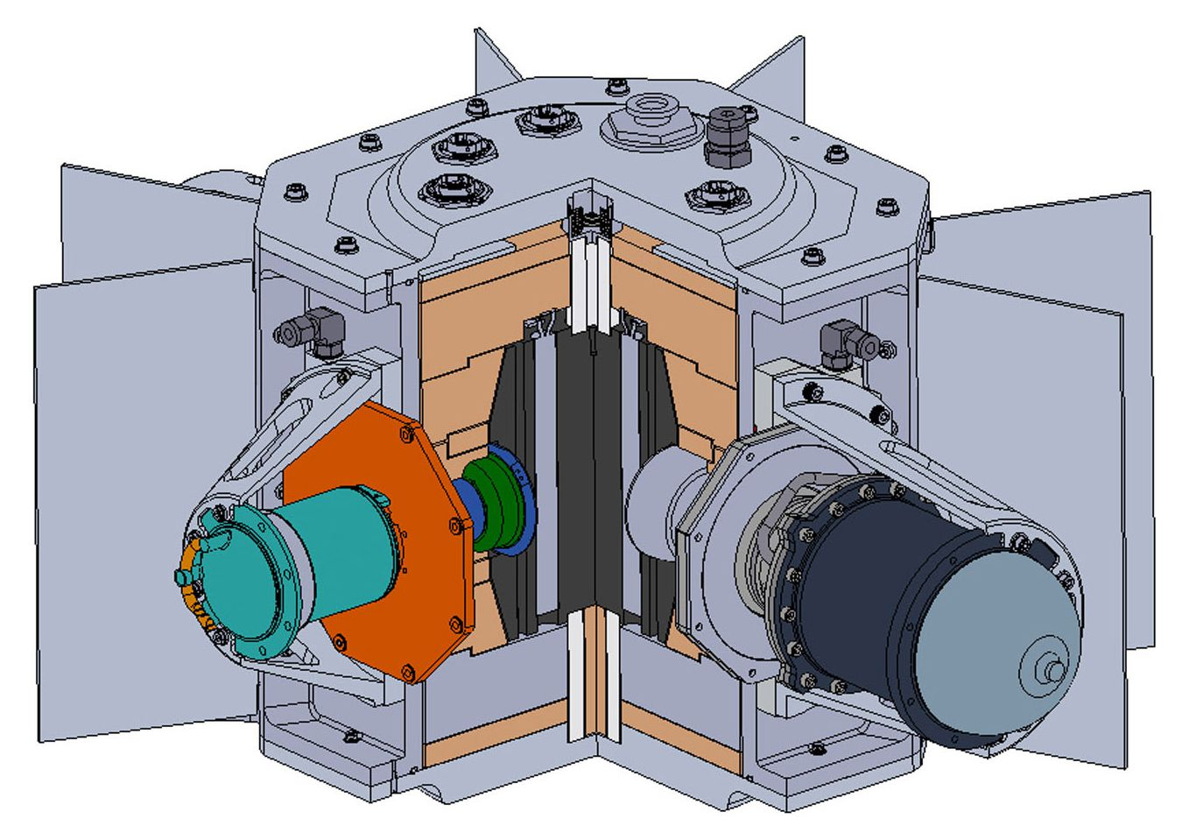

Our robot will be equipped with two DRPS (Dynamic RTG) units. This configuration provides sufficient power to operate the vibration system as well as the other subsystems of the robot.

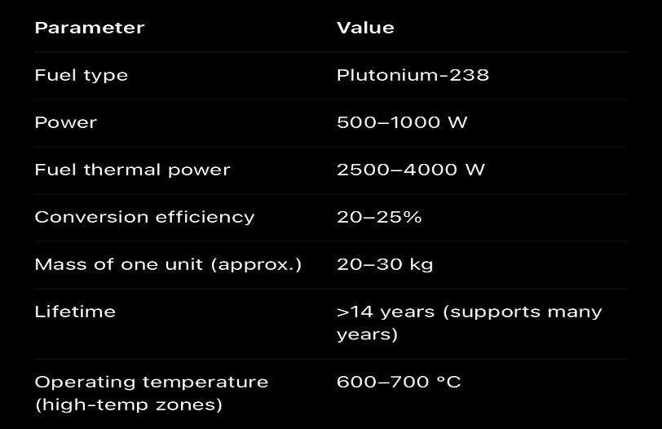

Figure 12 DRPS — Dynamic RTG Specifications

## Robot Chassis

To overcome various obstacles along its path, such as small rocks, uneven terrain, and sand, the robot is equipped with a **rocker-bogie chassis.** This design features independently suspended wheels and has proven highly effective in all previous Mars rover missions.

The robot employs a **6×6 wheeled chassis,** meaning all six wheels are driven and powered by electric motors. Additionally, the four corner wheels are equipped with **stepper motors** that allow rotation of up to 270 degrees, enabling the robot to perform precise turns and maneuvers.

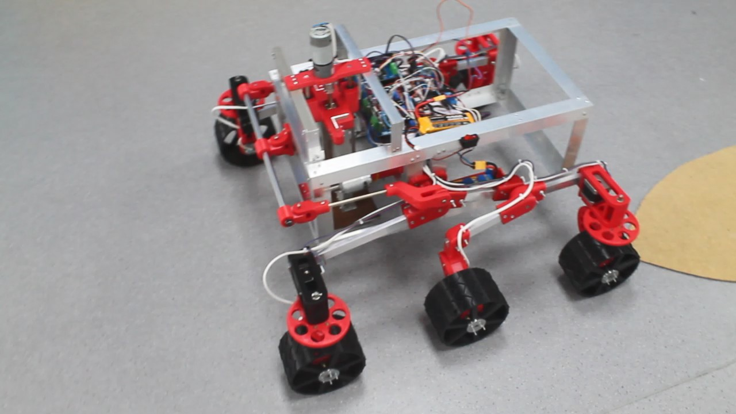

Figure 13 How the Rocker-bogie chassis looks

The robot will be remotely controlled through onboard cameras and by sending commands to the robot.

## Vibration Measurement Sensors

It operates based on the oscillation of a small coil around a magnet: the stronger the vibrations, the higher the generated current. This allows us to determine the intensity of incoming waves at different points of the surveyed area. The sensor is inserted into the regolith to a depth of 5 cm.

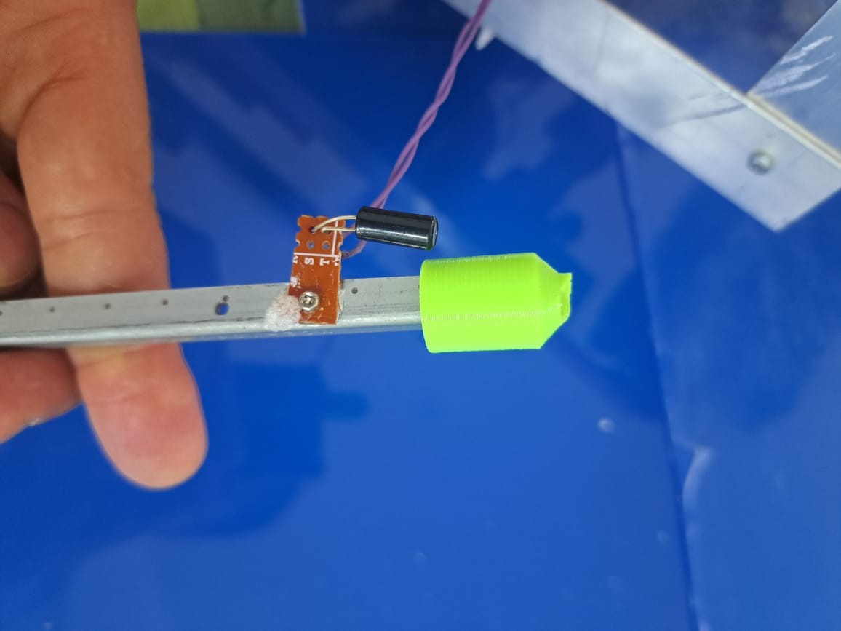

Figure 14 Example of a vibration measurement sensor used for subsurface wave detection.

## Use of Neural Networks

A neural network is a machine learning model that can learn patterns from images, data, and signals and make decisions based on this information. In robotics, neural networks are widely used for computer vision, navigation, and data analysis, because they allow the robot to react to the environment more intelligently instead of relying only on fixed algorithms.

In our project, neural networks are used to increase the autonomy of the overall process, especially for the movement of our Mars seismic rover. Since the Martian surface is uneven and full of rocks and obstacles, the robot must be able to recognize hazards and move safely without constant manual correction. For this purpose, we use the YOLO (You Only Look Once) framework for real-time object detection. Specifically, we implemented a fine-tuned YOLO26 model to detect obstacles during rover navigation on Mars-like terrain. This model allows the robot to identify rocks and surface obstacles in real time and avoid them while driving.

To train and adapt the model to a Mars environment, we used an open-source dataset from Roboflow Universe called the Mars Computer Vision Dataset. This dataset contains 593 labeled images focused on detecting rocks on the Martian surface. By training the model on this dataset, the neural network becomes more accurate in recognizing rocks and terrain features, which improves navigation safety and reduces the risk of collisions during autonomous movement.

As a result, the neural network helps the rover move more efficiently, avoid obstacles, and operate more autonomously in harsh planetary conditions. This reduces operator workload and makes the mission workflow more stable and reliable.  
In the future, we plan to implement an additional neural network focused on subsurface analysis. This second model will process seismic data collected by our sensors to study underground structures and detect possible caves or voids, which will significantly enhance the scientific capabilities of the rover.

# Robot Communication with Earth

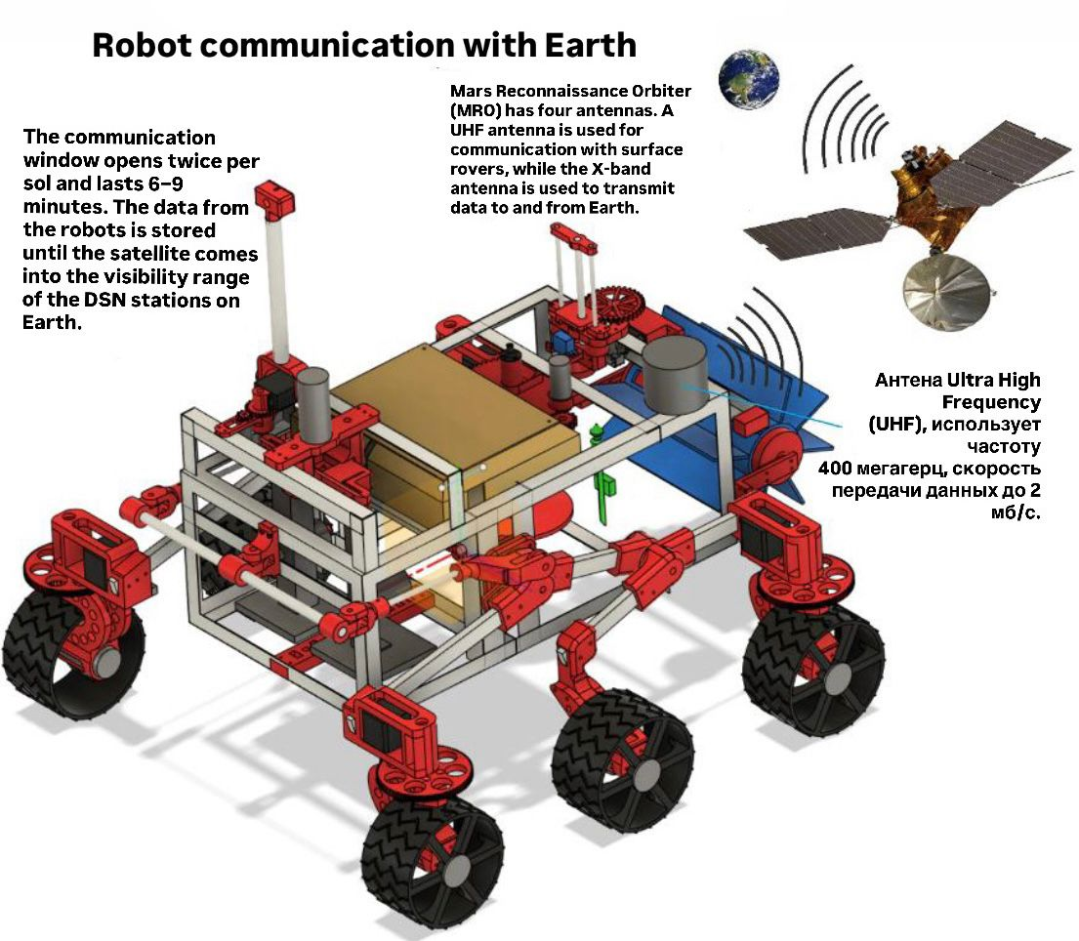

# Mission Launch Calculations

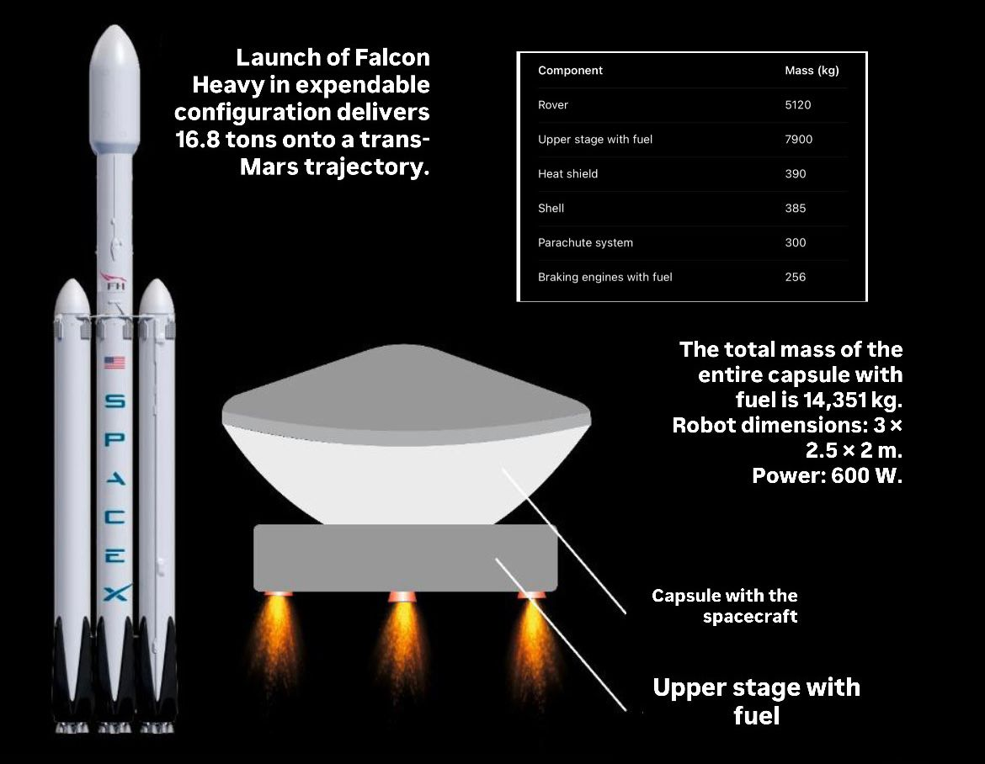

The calculations were made based on data from the **Perseverance mission**

# Flight and Landing Calculations of the Mission

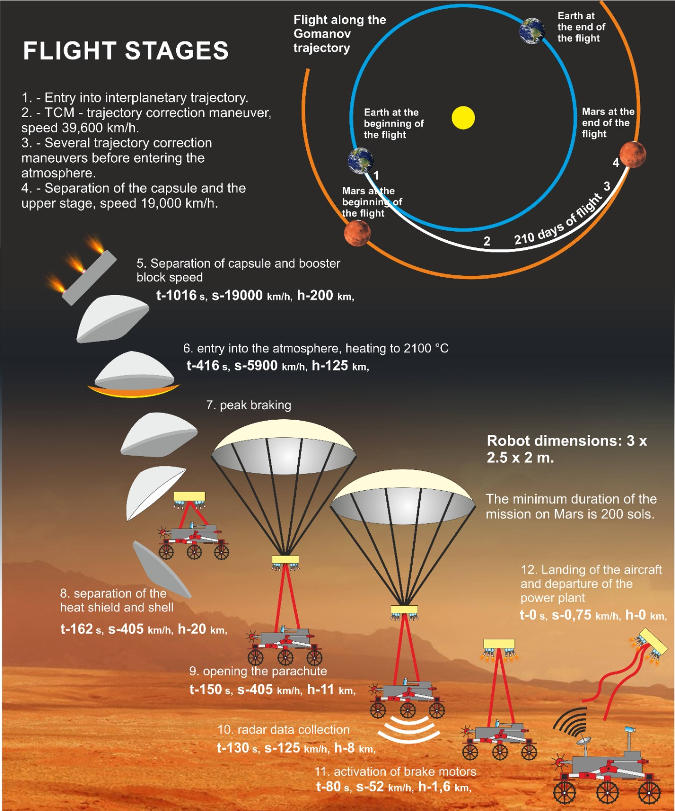

# Conclusions

Based on the work carried out, the calculations performed, and the experiments conducted on the test installation, we can confidently state that the proposed mission is capable of accurately determining the presence of lava tubes and defining their parameters.

In addition to the detection of lava tubes, the robot can also identify subsurface deposits of water ice at shallow depths beneath the regolith. This capability would be highly valuable for future missions, as water can be used to produce hydrogen fuel and oxygen for crewed expeditions.

The calculations demonstrate that the development of such a robot is technically feasible. The project is both important and highly relevant, as it may provide a definitive answer to whether it is possible to safely establish habitable colonies on Mars or the Moon.

The outcome of this work is a fully developed robotic system design that operates successfully under laboratory conditions.

The results of this project can be applied to the planning and design of future missions to the Red Planet.

# Sources

1. <https://en.wikipedia.org/wiki/SpaceX_Mars_colonization_program>
2. <https://en.wikipedia.org/wiki/Planetary_Exploration_of_China>
3. <https://www.jpl.nasa.gov/news/nasa-orbiter-finds-possible-cave-skylights-on-mars?>
4. <https://science.nasa.gov/mission/mer-opportunity/>